Difference betn text nd tinytext?
Fsp in date nd time?
Enum how to use?
Id bring to front of name,
Can we do addition of marks in INSERT statement?
Delete only column info---- update table_name set col=null
Can we do arithmetic operation in select statement and store in table at same time.

28/04 lect
The new table is not showing in database Ruchi
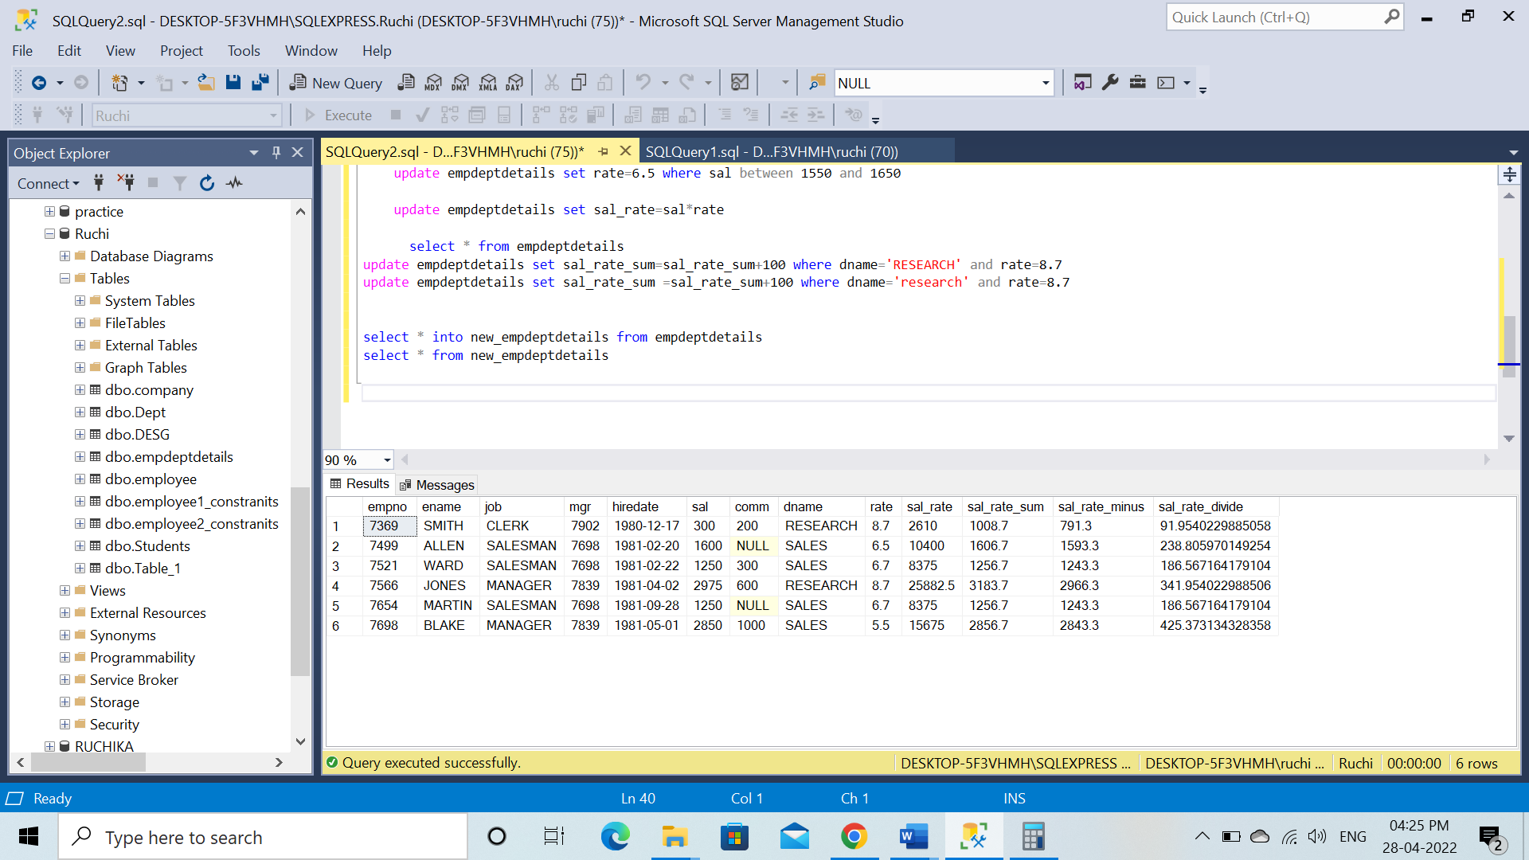

Where we can see this variables, if we have a lot of variable names?

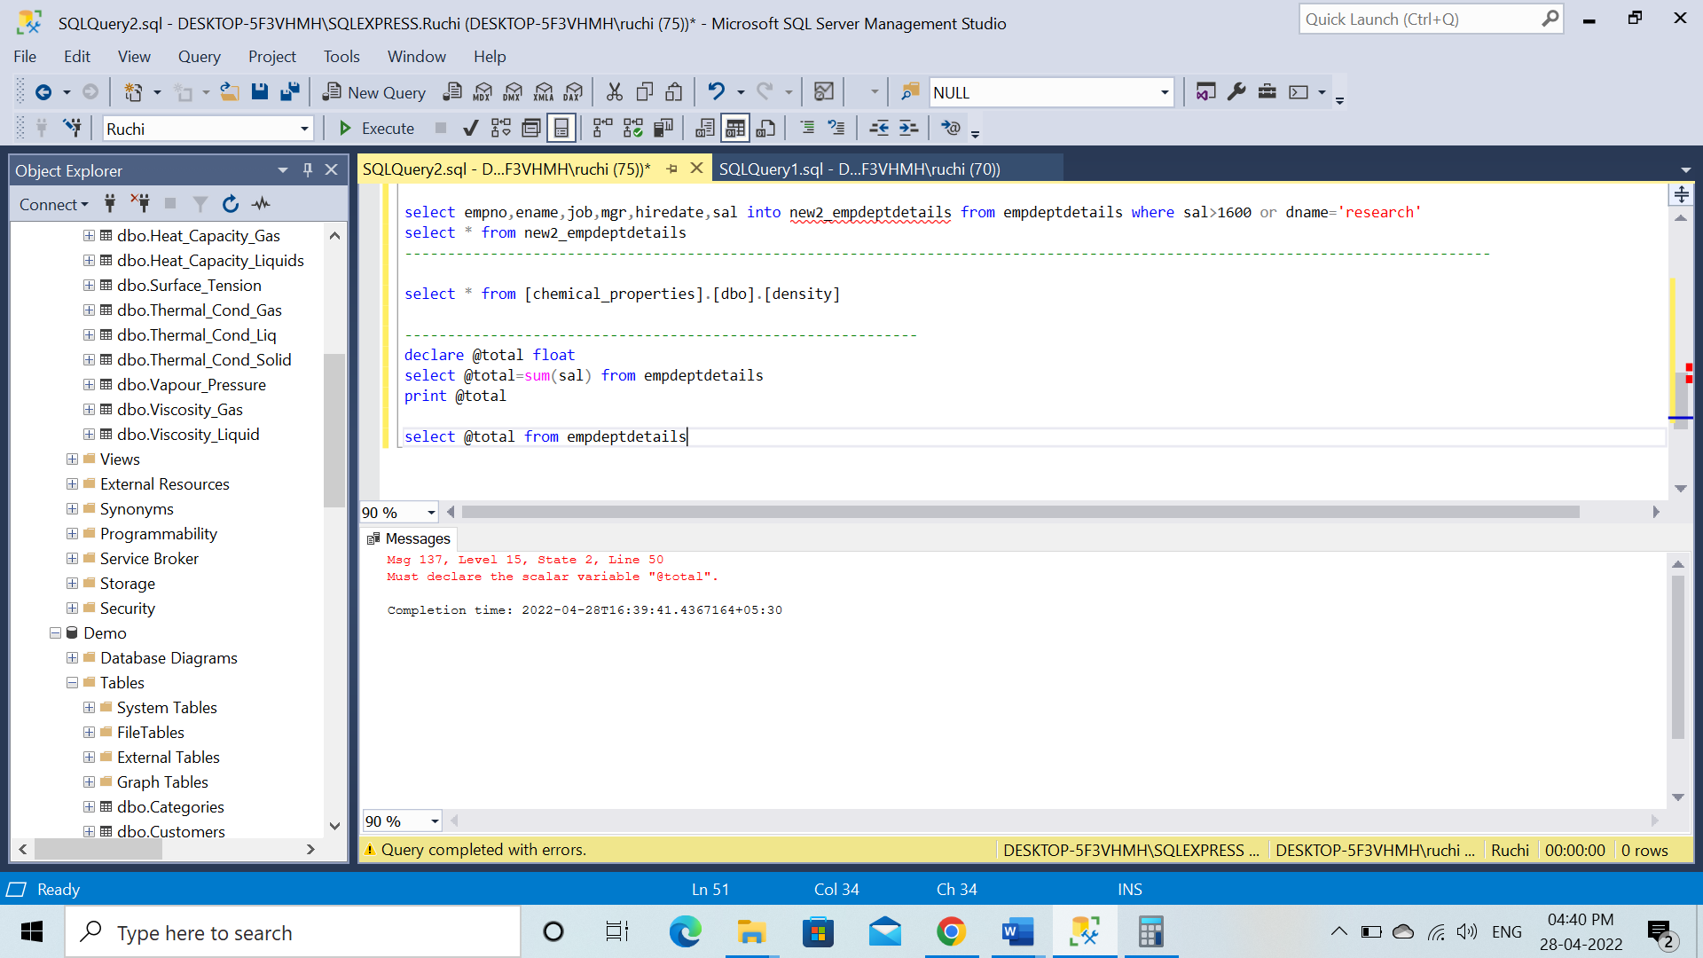

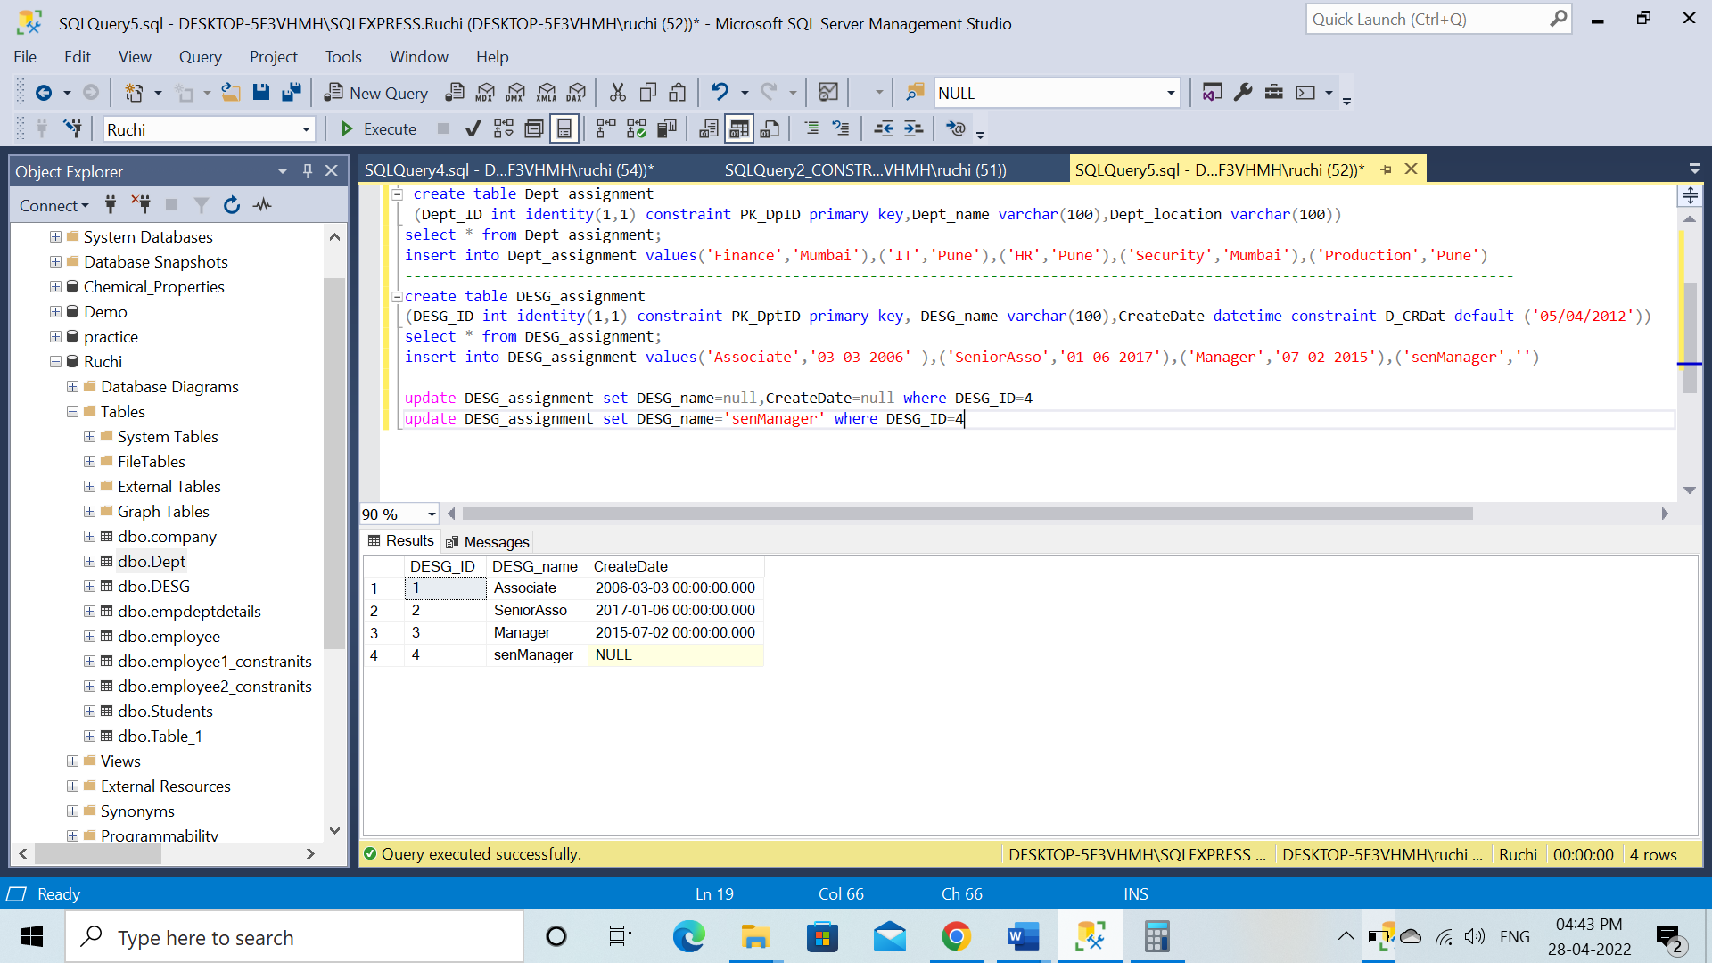

Default
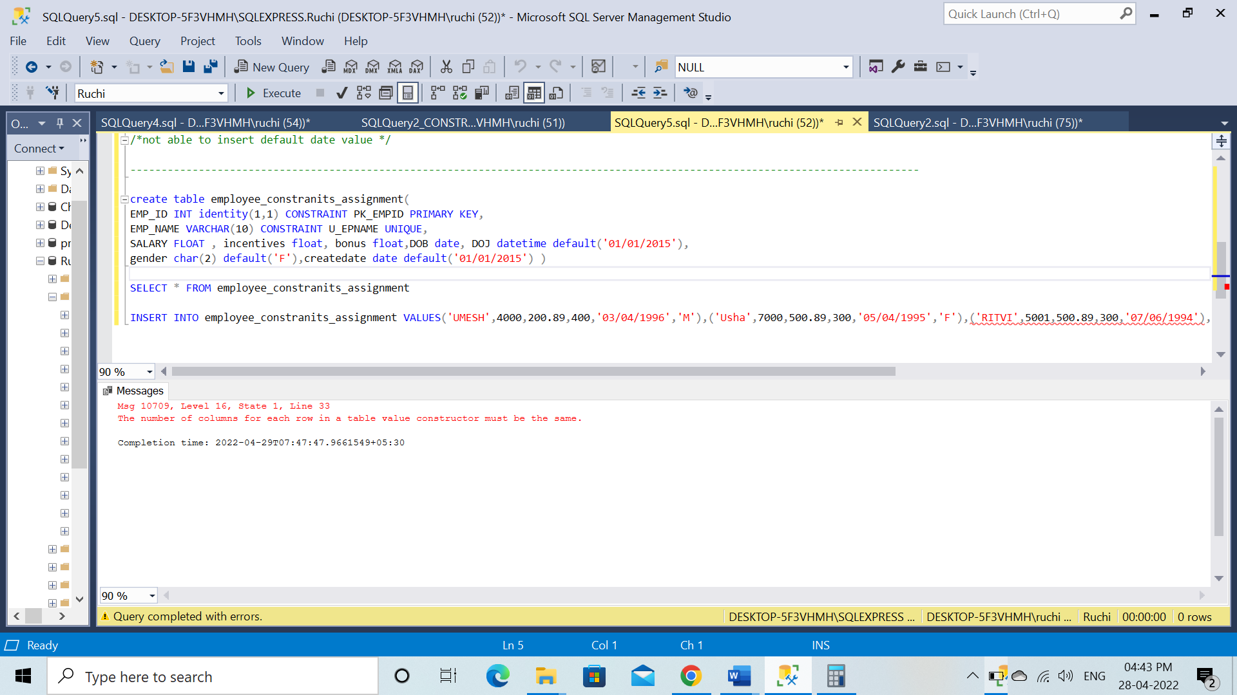

Default using problem
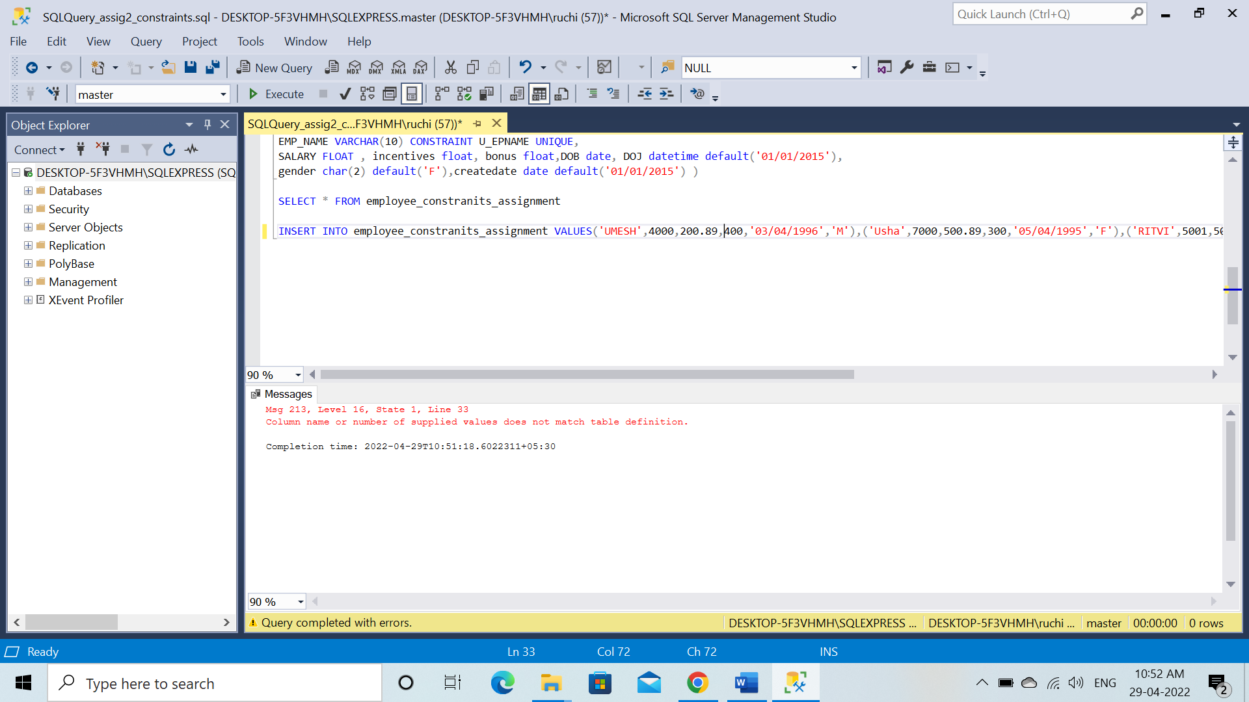

Can we drop the column directly without previously dropping the constraint of that column?-yes

Last question of assignment 2
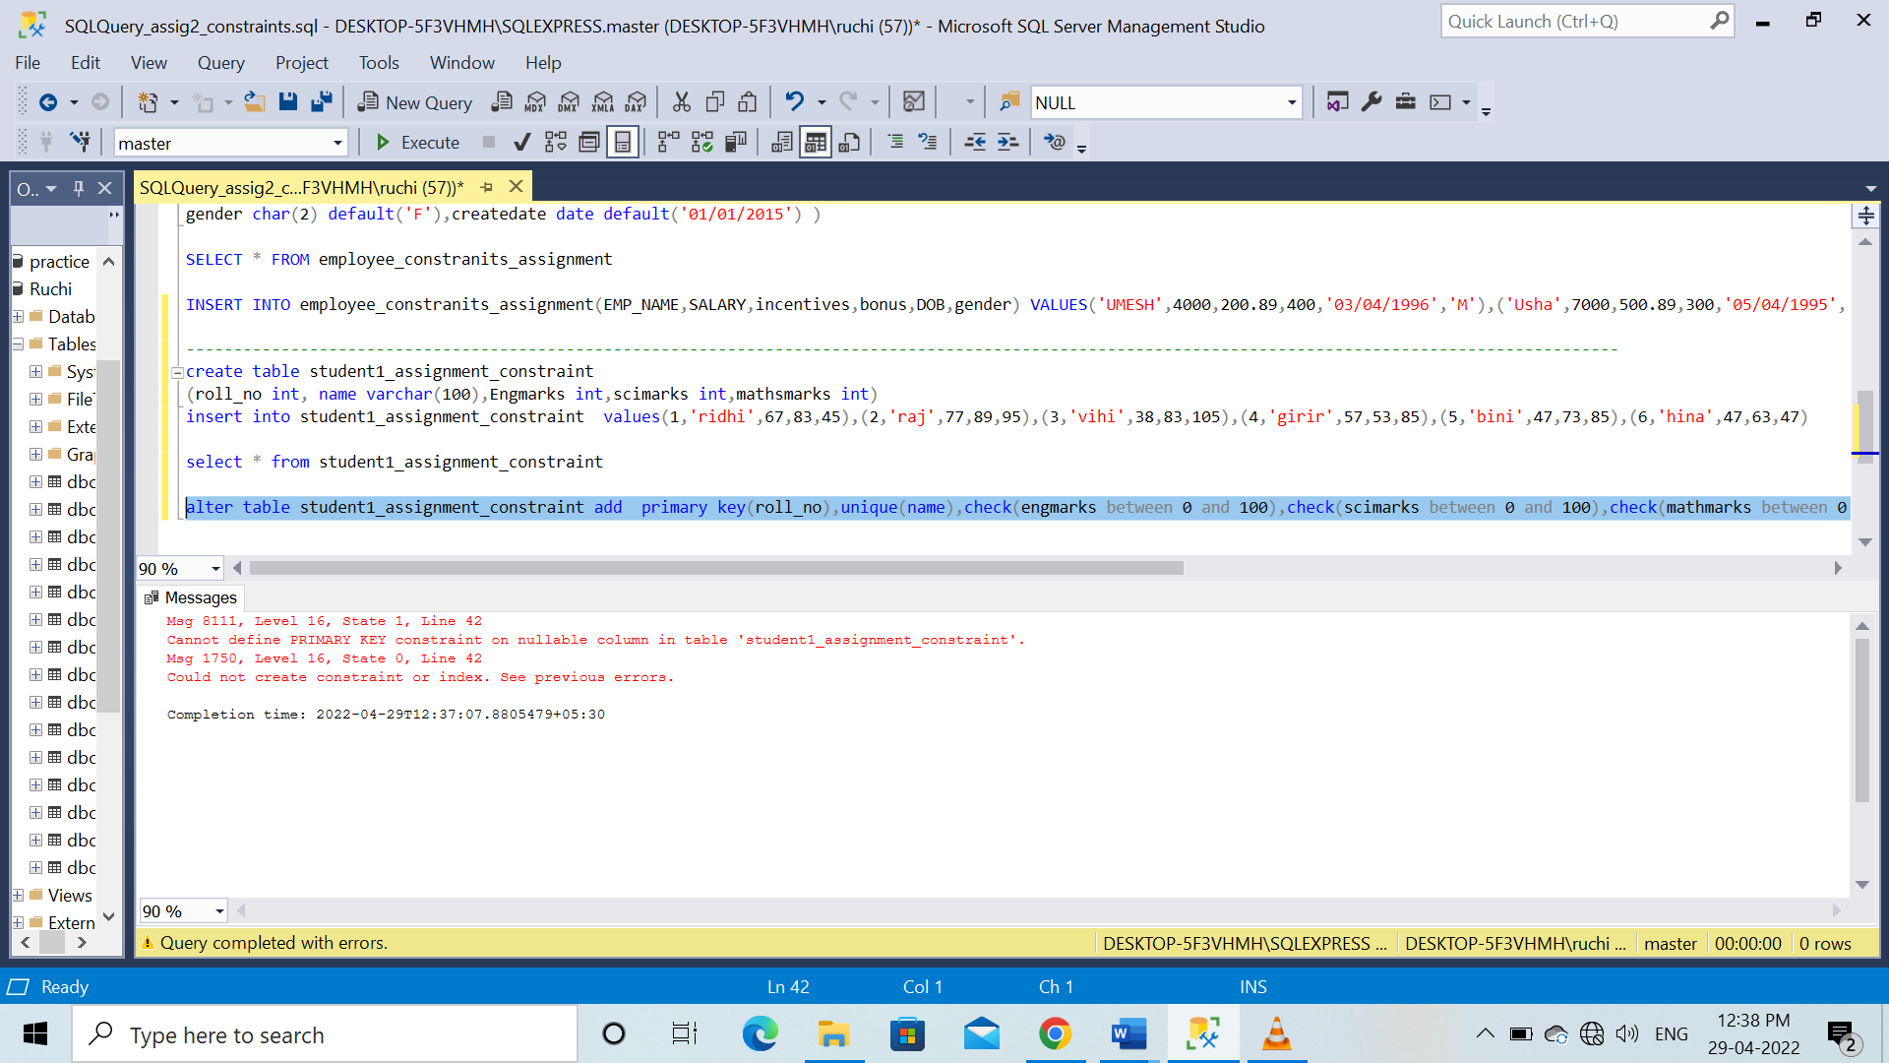

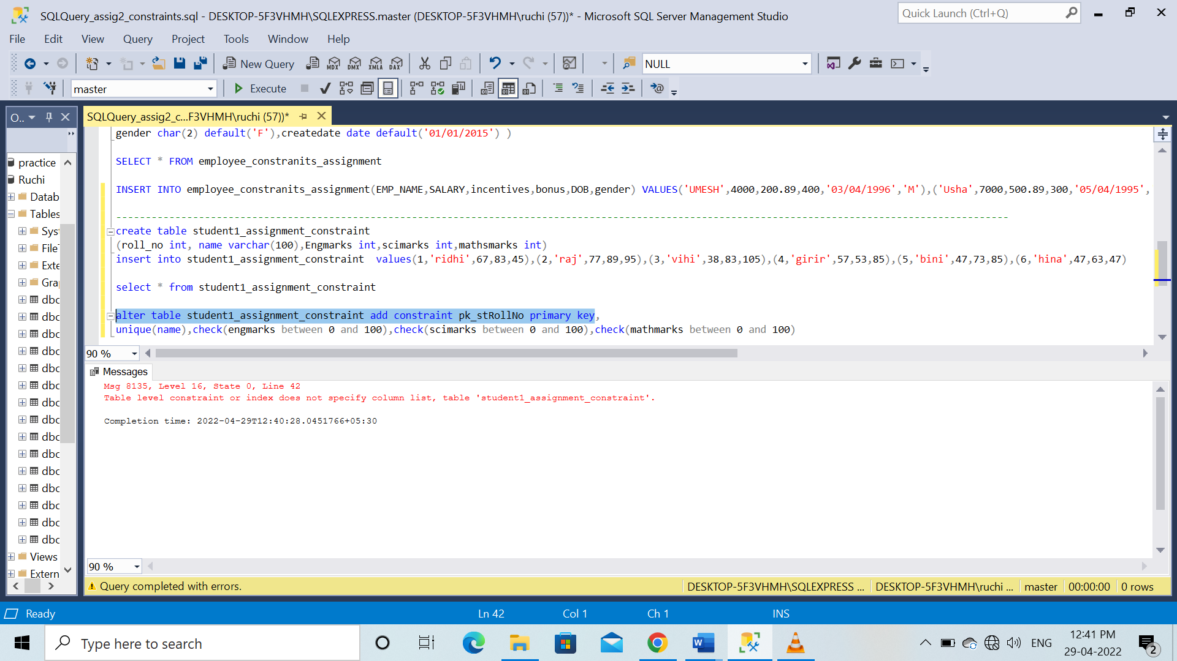
Ansr maybe
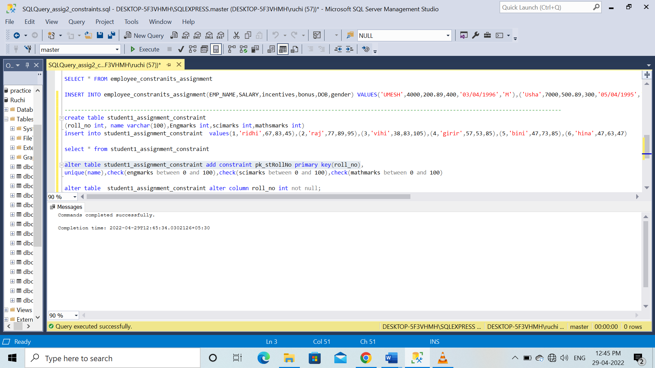

If two identical tables are in different database so if I copy the the data from 1 table to another then the data of 2nd table will replace or new data will add?

Select * into new_table from exist_table

--what if i want to divide it by month of date
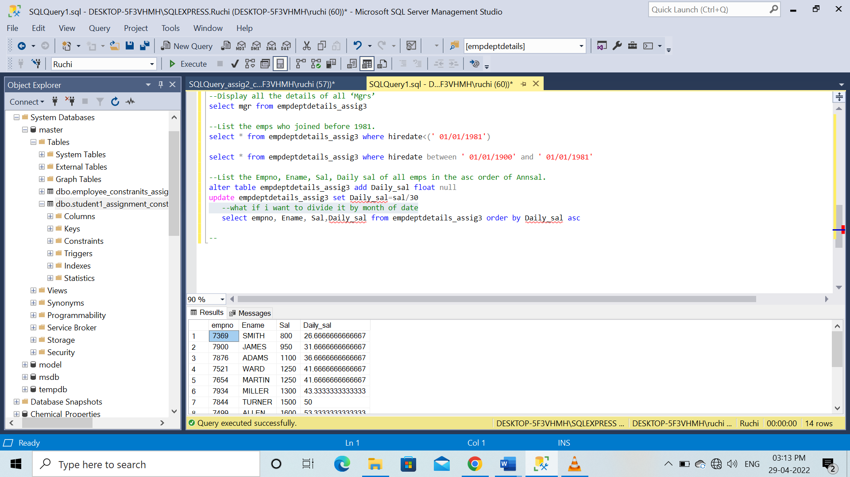
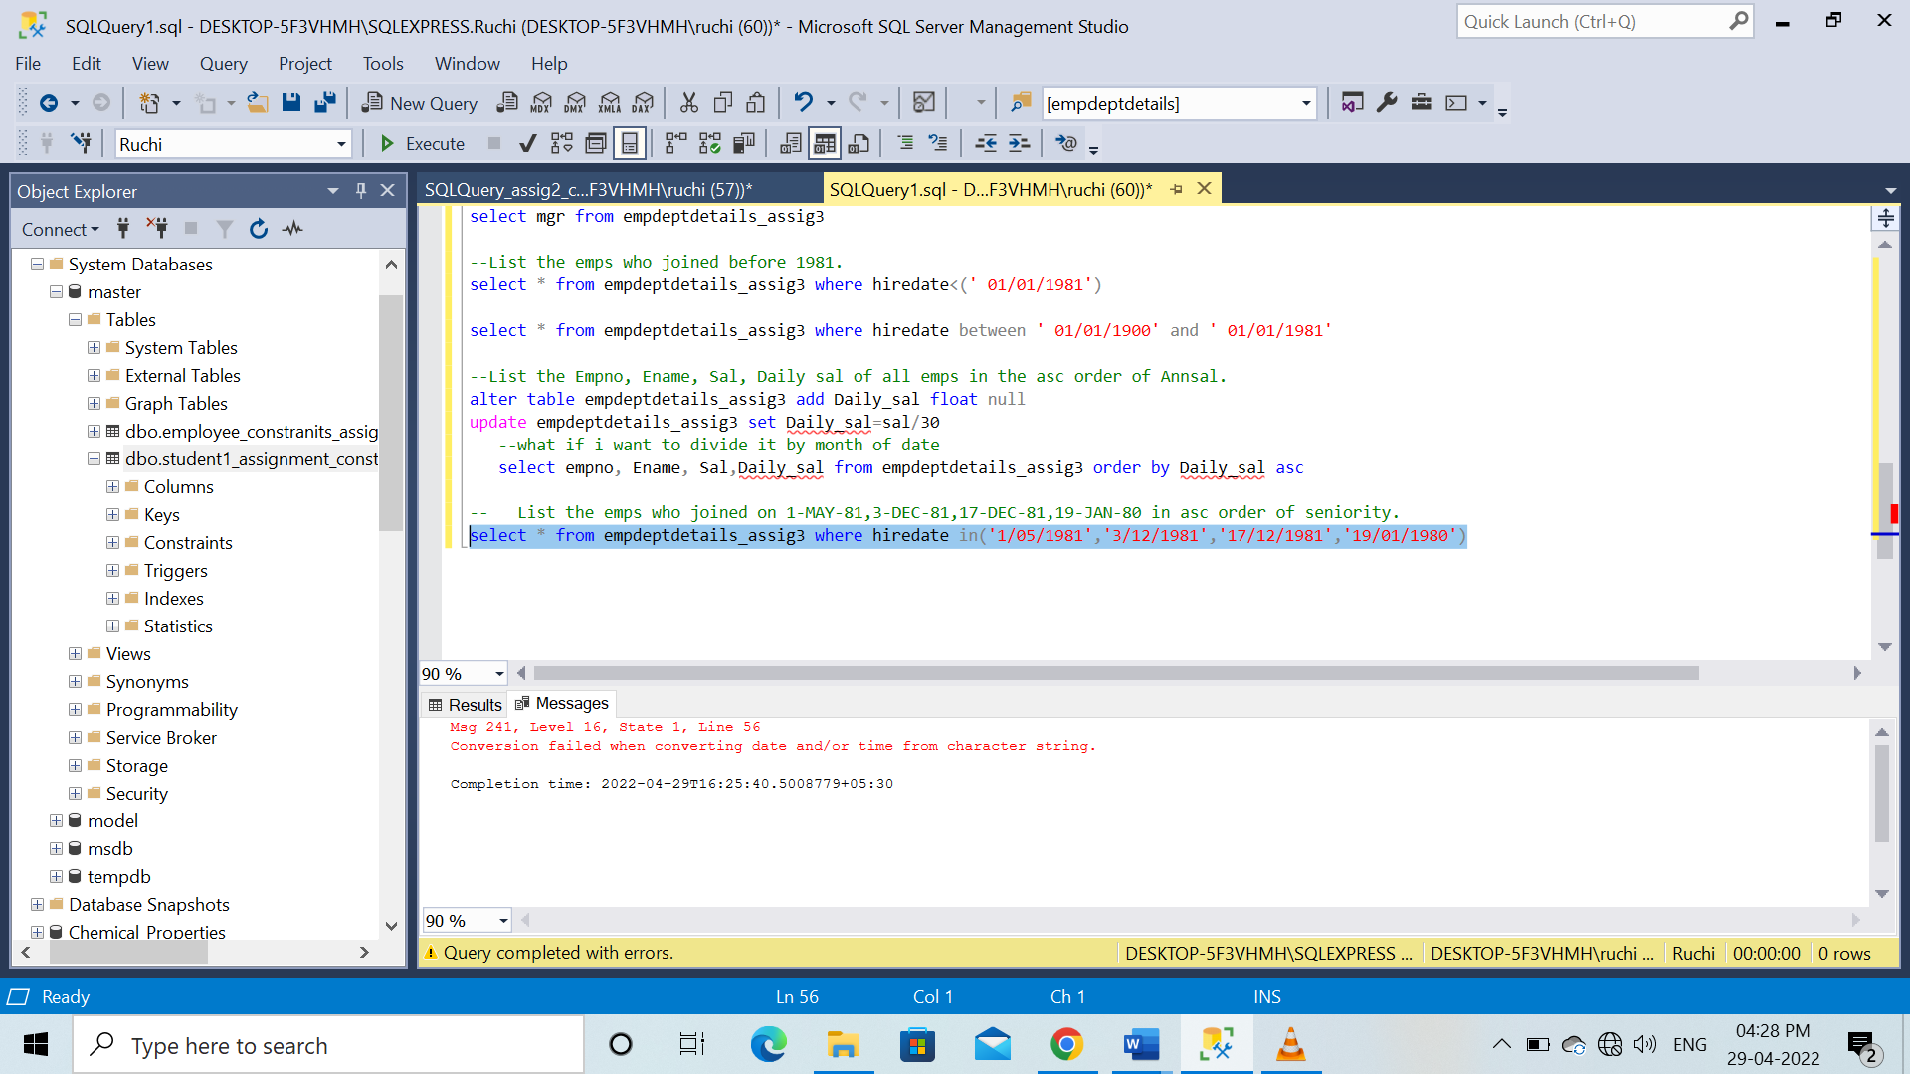
-------------------------------------------------------------------------------------------------------------------------------------------------------------------------------

How to unblock the empid if it get block.

Quotename(char string)
Str()
Unicode

Rand()
Round(n,p,t) truncated
Soundex(length)

Space(length)

How to remove identity property of column?
Self join
manager employee

empID 1 2 3 empid 1 2 3
empn sunil kapil san empn sunil kapil san
managid - 1 2 manager id - 1 2

mangr.EmpId=Employee.mangrId
manager.1(EmpId )=employee.1(mangrId)
Manager.Sunil=employee.kapil
emId empname mangrNm
1 sunil kapil
2 kapil sandeep
3 sandeep -

